LAB Logbook

Lab 1
Uber Data Breach (2022) – Cyberattack Case Study
One key link
Verizon Data Breach Investigations Report (DBIR): https://www.verizon.com/business/resources/reports/dbir/

Lab 2

Lab 3

- EDA plot
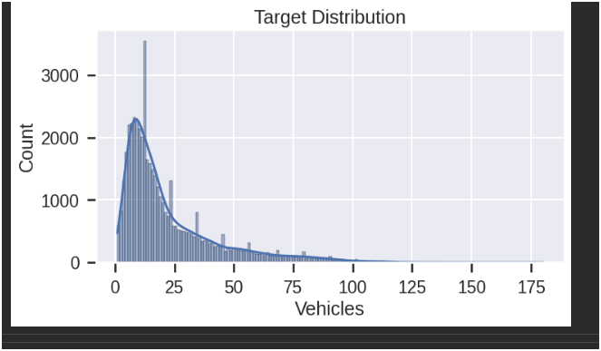

b) Snapshot of the results table comparing different machine learning models' performances.

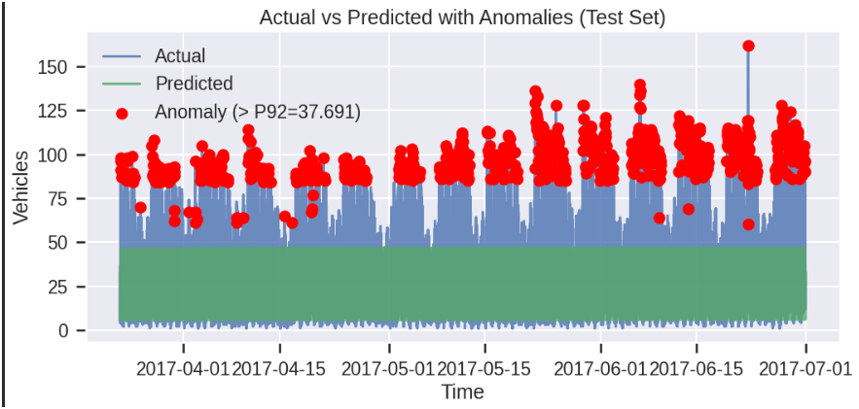

- Graph showing actual vs. predicted values with anomalies highlighted.

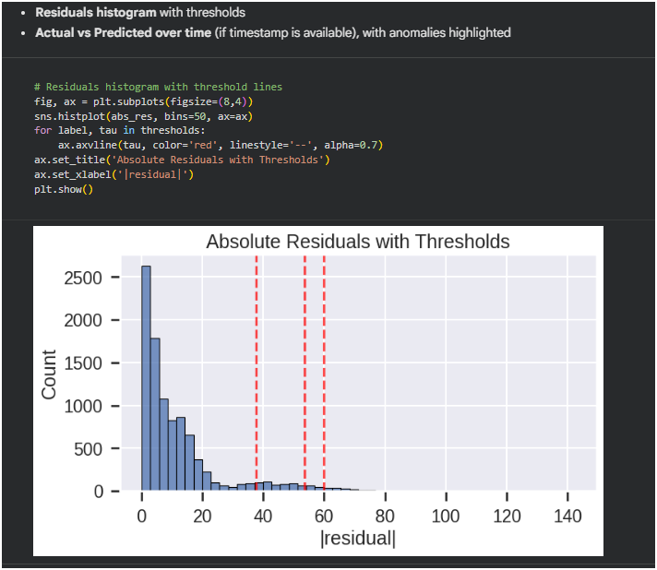
Lab 4
Plot a graph showing the model's accuracy for each epsilon value.

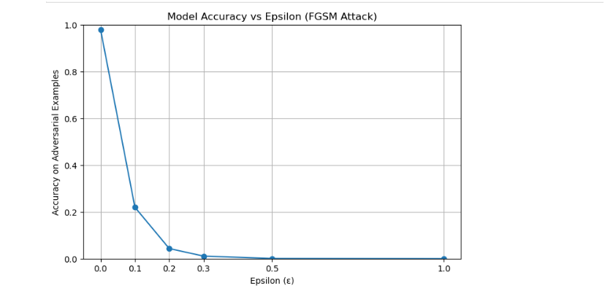
The model accuracy before and after data poisoning.
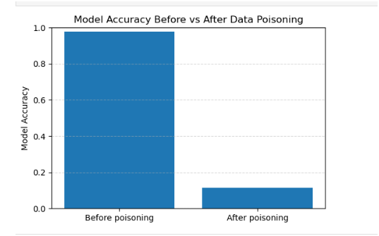
Discussion:
Effect of Increasing Epsilon on Model Accuracy
From the results and the Accuracy vs Epsilon graph, we observe a clear decreasing trend in accuracy as epsilon increases.
1️⃣ What happens as epsilon increases?
Small epsilon (e.g., 0.1):
The perturbations are very small, so the model’s accuracy remains relatively high. The adversarial noise is subtle and does not drastically change predictions.

Moderate epsilon (e.g., 0.3 – 0.5):
Accuracy drops more noticeably. The perturbations become strong enough to push inputs closer to or across the model’s decision boundaries.

Large epsilon (e.g., 1.0):
Accuracy decreases significantly. The adversarial perturbations strongly distort the input, leading to many misclassifications.

2️⃣ What does this tell us about model robustness?

The steady decrease in accuracy as epsilon increases indicates that:

The model is sensitive to adversarial perturbations.

Even small, carefully crafted changes to input data can reduce performance.

The model has limited robustness against adversarial attacks.

It likely relies on fragile feature patterns that can be easily manipulated.

3️⃣ Interpretation

This behavior suggests that the model was trained only on clean data and has not learned representations that are stable under perturbations. A robust model would show:

Slower accuracy degradation

Higher resistance to small epsilon values

More stable performance under attack

4️⃣ Conclusion

As the strength of adversarial perturbation increases, model accuracy decreases significantly. This demonstrates that the model is not inherently robust to adversarial attacks, and additional defense mechanisms such as adversarial training, regularization, or defensive preprocessing would be required to improve its resilience.

Lab 5

Lab 6

Lab 7

Lab 8

Lab 9

Lab 10

Lab 11

Lab 12

